

Bill To:
Delegate / Organization Name: Innovative Marketing Company Pvt Contact Person: Mr Richard Nyagwande
Phone Number: 0714421857
Email Address: richard@innovativemarketingcompany.co.zw

Event Name(s) : Zimbabwe 2.0 National AI Summit

Description  AI National Summit – Summit + Hotel + Dinner | Unit Price($)  720 | Attendees  ×2 | Sub-Tota($)  1440
Total | $1440

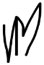
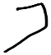
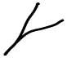
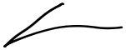
Authorized Signature (Ms. Mupikeni) AI Institute Adminstrator

Bank Name: POSB USD Account:
- Account Name: Artificial Intelligence Institute Africa

Account Number: 500008836495 Branch: POSB Main Branch, Harare, Zimbabwe Payment Terms:
- Kindly note that the Payment should made at the latest by 30 May 2026
- Please use the invoice number as payment reference

Thank you! We look forward to a successful Summit.

